STAKEHOLDER ANALYSIS
CMNS 4530- ORGANIZATIONAL BEHAVIOUR
Hamida Marufu T00658389
The Mustard Seed is a Christian non-profit organisation that has been catering for individuals who are experiencing homelessness and poverty since 1984. The Mustard seed operates in five cities across Alberta and British Columbia. All locations offer an expansive range of programs and services to the most valuable community members. Mustard seed looks at meeting the physical, mental, and spiritual needs ensuring greater health and independence.
The mission is to build hope and well-being for most vulnerable citizens though Jesus’ love. The core values are Christ Centredness, Transparency, Accountability and treating all with respect and open communication. Homeless shelters are in the services industry as they cater for the homeless service agency. This report will outline what The Mustard Seed Kamloops is about and how we have different stakeholders who contribute in ways that help reduce homelessness within the community. We will learn the importance of having organizations like this within the community and how they play an important role in making the society accessible for those who happen to experience homelessness.
In this industry, we have stakeholders who inject funds into the organization and the result of that would be ensuring that basic needs in the community are met. Donors and Grants are one of the stakeholders, these donors essentially give into the Mustard seed whether the donation is big or small. This may be done either in cash or kind. The donations that the Donors and Grant Givers invest cater for the daily functioning of the organization. Food donations make a huge impact as meals are served three times a day and money collected may also cater for the ingredients that will be used to prepare that food. In the 2022 report, a meal is said to cost $5.38. Donors and Grant givers are open to all, some make huge donations and there are some who give what the can. Program Directors are those that are on the ground when it comes to the daily running of the organization. Program Directors are those that communicate with the clients and other stakeholders of the organization. Program directors look at the health and wellness, permanent housing, shelter, community engagement, meals, employment, clothing, and spiritual care. These are the different departments that the program coordinators control and make sure there is enough employment, and the jobs are fulfilled. The government is an important stakeholder as they contribute by assisting the Mustard Seed with some funding especially when it comes to housing. Recently, the weather has been at extremes and with the number homeless individuals, emergency shelters have been opened and the government reached out to The Mustard Seed to assist in making sure everyone is housed during this period. As the mustard Seed, working alongside the government has created a good brand image and added growth to the organisation overall.
Paid staff are stakeholders that are more engaged with the clients at most, they are the ones that deal with preparing meals, preventing anti-social behaviours. Paid staff are also there to oversee the clients as they are the ones that have full engagement to the clients. Staff also contribute greatly to the growth of the shelter as they address clients and make sure their needs are met. Volunteers are always welcome, and, in most cases, we have churches and individuals who come and engage with clients either by talking to them, coming to assist in the kitchen and because we are a Christian based organization, some individuals come and preach the gospel to clients. Every second Sunday of the month, the seventh day Adventist church comes in with a healthy vegetarian meal for the clients. The community goes hand in hand with the volunteers as the shelter is accepting to donations at any time. The drop off points are very convenient, and nothing is discarded. The community is shaped by the people, their participation is what helps solve some of the social issues that need to be solved in the community.
Saliency looks at how visible or prominent a stakeholder is to an organization and opportunities such as identifying interests and being able to solve potential risks before they occur. This also helps to make mechanisms have a potential influence on other stakeholders and controls negative stakeholders as well as their adverse effects on what is being worked on. Challenges associated with the saliency model is that there are communication breakdowns therefore it is important that roles are defined clearly, and the organization is running smoothly. Our latent stakeholder groups which possess one attribute consist of Dominant stakeholders, Discretionary stakeholders, and Demanding stakeholders.
Within The Mustard Seed our Stakeholders Dominant stakeholder is the Donors and the Grant givers. They spend their money giving it to the organization and as a result that is used to cater for the needs of the organization. They have little to no interaction to clients and in most cases, donors prefer to remain anonymous. Yearly reports presented by the organization is how they know what their contribution has gone towards. Discretionary stakeholders in this organization would be the paid staff, they have interactions with the clients however they do not have as much power on legitimate claims to do with the organization. Suggestions are taken into consideration however to a large extent they have no power to influence the organization. Our Demanding Stakeholders are the community members. Some living withing the community do not really understand why we receive funding from the government and other donors. As a result, there is always negative comments on social media and within the community about how accessing services from the Mustard Seed is not beneficial. Clients are not forced to access services as a result some that do not tend to have “noise”.
Expectant groups consist of Dominant Stakeholders, Dangerous Stakeholders and Dependant Stakeholders. Dominant Stakeholders within The Mustard Seed are the Program Directors as they have both the powerful and legitimate claims giving them a strong influence on the organization. They have direct communication with the executives and the clients if need be. They have the power to decide on growth ideas or declining projects that are difficult to execute. The size of the labour force is dependent on them, and they overall mould the relationships between other stakeholders. Dangerous Stakeholders would be the government as there has been attempts where funds have been requested for projects and last-minute changes lead to getting a decline once all has been set up. This has been due to external forces such as the public making rages about the amount of funding that goes towards the homeless population. Dependant stakeholders are those who lack power, and this population is the community. The community may be misled by social media and what is posted about the Mustard Seed and hence as an organization we tend to block out those who have false claims and those who have negative comments about the homeless population and their situation.
The Definitive Stakeholder would be the Executive Directors as they overlook the whole Mustard Seed. They are powerful and legitimate stakeholders who need to be communicated with about major projects and they too have communication with the Donors and Grant givers to encourage them to keep investing into the Mustard Seed. Executive Directors have been classified as Dominant stakeholders as they become active when they feel some interests are not being served by the managers of the organization which they potentially hold stock.
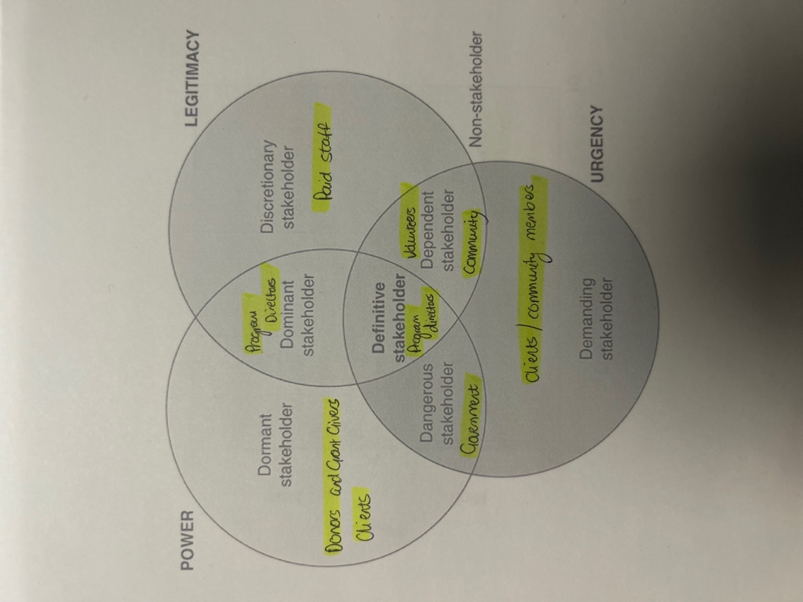
In relation to the power matrix communication must be done between the stakeholders to keep them informed on how the Organization is currently functioning. Quadrant A will consist of the community and the volunteers. If the community is affected by the shelters and the operations of the shelter, the group that answers to that would be the government. Volunteers will only communicate to the organization when they want to come in and volunteer. In return the organization will communicate back to the volunteers which day is suitable to come in and offer that extra hand. Quadrant B consists of the paid staff, it is always good to keep the staff that are engaged with clients informed about what will be going on within the organization and in return Program Directors know which areas need to be addressed and general statistics of the organization.
Quadrant C is considered the most important as most of the funding comes from them, it is essential that they are kept satisfied and they can keep injecting into organization despite their lack of interest it is important to produce results. Program Directors and the government are the key players as the Program Directors keep all the other stakeholders informed of what is going on in the organization and the Government is that supporting backbone If any shortfalls occur along with future project plans that need land and signatures.
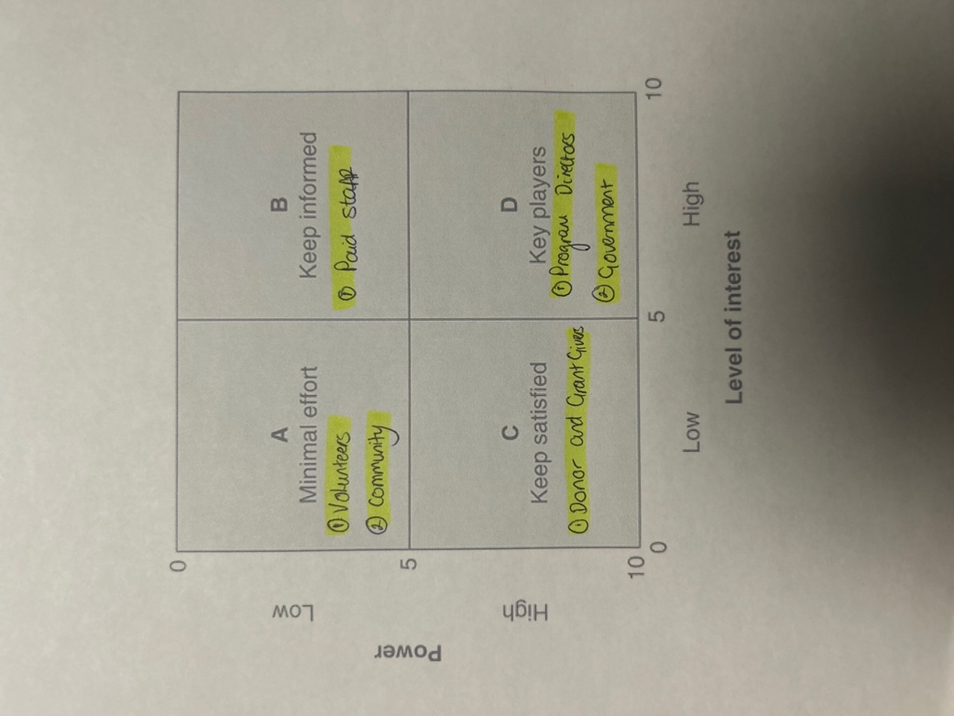
Donors and Grant Givers are communicated with through newsletters and reports that are done yearly and monthly to keep them Informed about how the organization is doing (Image Below). Paid staff have open discussions and meetings, this is the time used to discuss any issues and to reinforce the company policy and ethos. Volunteers and Community members are communicated with through social media conversations and possible consultations upon request to those who want to know more about The Mustard Seed.
